|  |  |
| --- | --- |
| Product name | Confidentiality Level |
| Internal disclosure |
| HEY2-W09 | Total pages: 12 |

**HONOR HEY2-W09 def,spcseas Upgrade Guide**

|  |  |  |  |
| --- | --- | --- | --- |
| **Prepared by** | **Wu Guoping 00013208**  **Wang Yanzhao 00013378** |  |  |
| **Review by** | **Li Shubin 00013108** |  |  |
| **Approved by** |  |  |  |

# Revision History

| Date | Version | Section | Description | Author |
| --- | --- | --- | --- | --- |
| 2021/02/06 | V1.0 |  | First draft | **Wang Yanzhao 00013378**  **Wu Guoping 00013208** |
| 2021/04/07 | V1.1 | 6 | Added screenshots (Chinese) for the upgrade steps | **Wang Yanzhao 00013378**  **Wu Guoping 00013208** |
|  |  |  |  |  |
|  |  |  |  |  |
|  |  |  |  |  |
|  |  |  |  |  |
|  |  |  |  |  |

**Contents**

Revision History 1

1 Upgrade precautions 3

**1.1** **Precaution 1** 3

**1.2** **Precaution 2** 3

2 Version Requirement 3

**2.1** **Tablet version requirement** 3

**2.2** **Software requirement** 3

3 Upgrade environment 4

4 Checking the Vendor Country Info and product model 4

**4.1** **Checking the Vendor Country Info** 4

**4.2** **Check the product model** 5

5 Upgrade description 5

6 Upgrade steps 6

**6.1** **Normal upgrade with SD card** 6

**6.2** **Forced upgrade with SD card** 7

**6.3** **Normal OTG upgrade** 8

**6.4** **Forced OTG upgrade** 10

**6.5** **Reset tablet** 11

7 Verification and troubleshooting 11

**7.1** **Version check** 11

**7.2** **Basic function check** 11

**7.3** **Troubleshooting upgrade issues** 11

**7.4** **Using at commends and writing customized information** 12

# 1 Upgrade precautions

## **Precaution 1**

Read the feature description before performing the upgrade.

1. **Software version**

Ensure that the tablet is running on stock, unmodified Honor firmware, otherwise the upgrade may fail, or unknown errors may occur.

Do not attempt to upgrade your tablet with any customized firmware intended for countries outside your country of residence. Otherwise the upgrade may fail, or unknown errors may occur.

1. **Hardware version**

This upgrade package is intended for the HEY2-W09 model(s) only, using it to upgrade other tablets may cause boot failures.

## **Precaution 2**

1. Updating your tablet will erase all user data. Back up your data before the upgrade.

Ensure that the battery is charged to more than 30% at the beginning of the upgrade.

2. As the single SIM and dual SIM versions of MAGIC OS are not interchangeable, be sure to use the correct update package. In case a wrong version was used, contact your local Honor service center.

3. Note that the cota subnetwork packages for single /dual SIM versions are also different.

# Version Requirement

## **Tablet version requirement**

Tablet software version must be lower than the upgrade package.

## **Software requirement**

|  |
| --- |
| **Upgrade software list** |
| \---dload  | update_sd_base.zip  | HEY2-W09_def_spcseas  | update_sd_cust_HEY2-W09_def_spcseas.zip  | update_sd_preload_HEY2-W09_def_spcseas_R2.zip |

Both the tablet and the upgrade package contain a customization package and a preload package. The names of these packages indicate their intended model and Vendor Country Info. For the upgrade to be successful, this information on all four files names (in the tablet and in the upgrade package) must match. The directory where the upgrade package is copied to in the USB flash drive or SD card must be the same as the directory structure described above.

# Upgrade environment

We recommend to first try updating with the OTG adaptor + flash drive method. The SD card method can also be used if the tablet has a SD card slot.

1. Before updating using the OTG adaptor + flash drive method, check if the flash drive is working correctly and has more than 8GB of available space. We recommend using flash drives from well-known brands for this process. Please ensure that the OTG adaptor matches the port type of the tablet. The adapter shown below only works with tablets that have Type-C ports.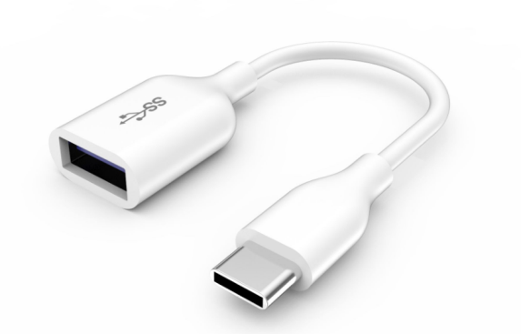

Type-C-2-OTG

2.If you are upgrading with the SD card method, check whether the SD card is working correctly and has more than 8GB of space available before proceeding. We recommend using flash drives from well-known brands for this process.

# Checking the Vendor Country Info and product model

## **Checking the Vendor Country Info**

* + - 1. Method 1：

Step 1：Type in ()()2846579()() on the tablet’s [Calculator](https://cn.bing.com/dict/search?q=Calculator&FORM=BDVSP6&cc=cn) [interface](https://cn.bing.com/dict/search?q=interface&FORM=BDVSP6&cc=cn) to access the project menu.

Step 2：Select 3. Network information Query

Step 3：Select 4. Vendor Country Info

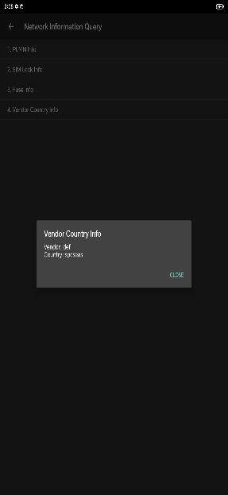

2. Method 2：Check by using the “at^vendorcountry?” command. See section 7.4 for details.

## **Check the product model**

Check the tablet’s internal model number with the “at^devmodel?” command. See section 7.4for details.

If the Vendor Country Info or the internal model number found by performing the steps described in section 4.1 and 4.2 does not match the the names of the customization package and the preload package, but the upgrade package is confirmed to be correct, you need to change the customization information of the tablet by using at command and ensure that it matches the upgrade package name, see 7.4 for details.

**Note：If the tablet is running on Board Software and has no model or Vendor Country Info by default, this information can be obtained from the Simlock list or by referring to the name of the upgrade package. Then, refer to section 7.4 on how to overwrite the Vendor Country Info and model number before proceeding with the upgrade.**

# Upgrade description

There are two upgrade types：normal or forced upgrade.

1. A normal upgrade can be started from the tablet’s project menu.

2. A forced upgrade can be selected from the tablet’s recovery menu after performing buttons presses.

# Upgrade steps

## **Normal upgrade with SD card**

Step 1： Find an SD card (preferably from well-known brands) with 8GB or more space available.

Step 2: Format this card (optional) to exFAT, NTFS, or FAT32 file system (exFAT is recommended).

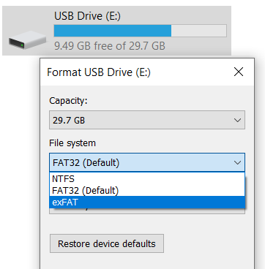

Step 3：Check if the dload folder is complete with all its contents, then copy it to the SD card's root directory.

Step 4：Verify that all files and folders were successfully copied (refer to section 2.2).

Step 5：Insert SD card into tablet, then type in ()()2846579()() on the tablet’s [Calculator](https://cn.bing.com/dict/search?q=Calculator&FORM=BDVSP6&cc=cn) [interface](https://cn.bing.com/dict/search?q=interface&FORM=BDVSP6&cc=cn) -> Project menu -> Software Upgrade -> Memory card Upgrade -> OK.

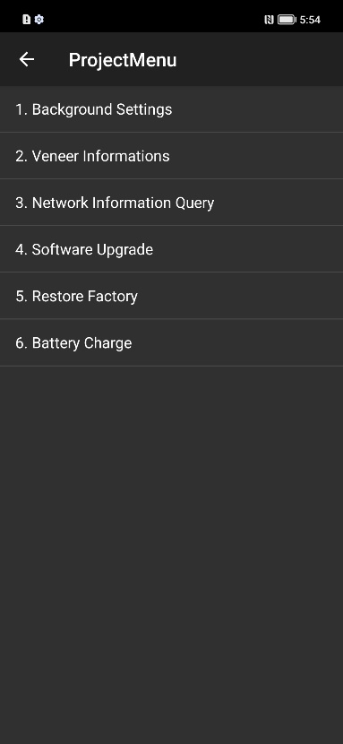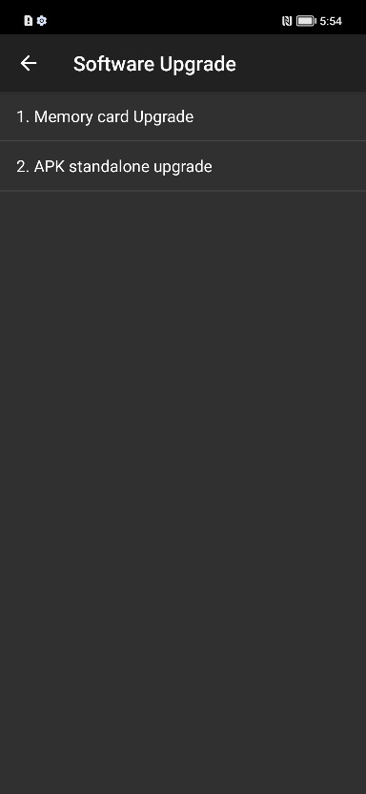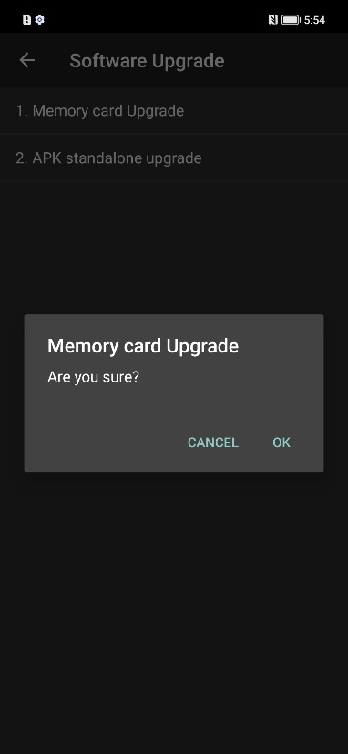

Step 6：Wait while the upgrade is being installed. The tablet will automatically reboot when the installation is complete. Note：Keep the SD card inserted until the screen shows “Update success.”

For MAGIC OS, the following screens will be shown:

. 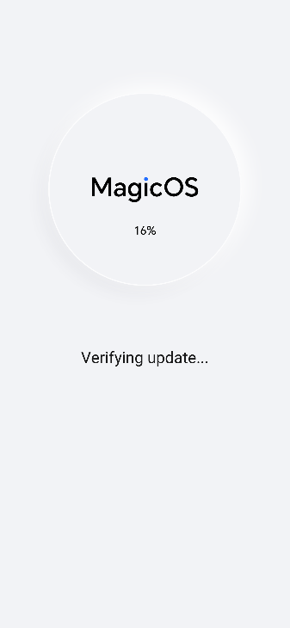手机屏幕截图

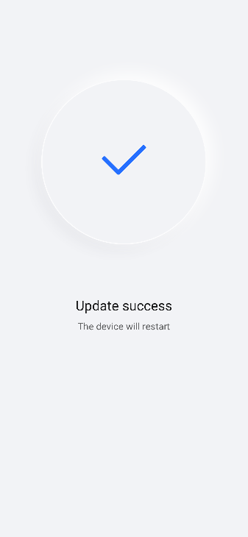

## **Forced upgrade with SD card**

Step 1: Find an SD card (preferably from well-known brands) with 8GB or more space available.

Step 2: Format this card (optional) to exFAT, NTFS, or FAT32 file system (exFAT is recommended).



Step 3: Check if the dload folder is complete with all its contents, then copy it to the SD card's root directory.

Step 4: Verify that all files and folders were successfully copied (refer to section 2.2).

Step 5: Insert SD card into the tablet while it is powered off, then press the Volume up button and the Power button simultaneously to go into the recovery menu and select “Update mode”--> Input “yes”, “Enter update mode”-->”Memory card/OTG update mode” to begin the upgrade.

Step 6：Wait while the upgrade is being installed. The tablet will automatically reboot when the installation is complete. Note：Keep the SD card inserted until the screen shows “Update success.”

For MAGIC OS, the following screens will be shown:

手机屏幕截图

## **Normal OTG upgrade**

Step 1： Find a flash drive (preferably from well-known brands) with 8GB or more space available.

Step 2: Format this drive (optional) to exFAT, NTFS, or FAT32 file system (exFAT is recommended).



Step 3: Check if the dload folder is complete with all its contents, then copy it to the flash drive's root directory.

Step 4: Verify that all files and folders were successfully copied (refer to section 2.2).

Step 5: Connect the OTG adaptor to the tablet, then the flash drive to the OTG adaptor. Go to the tablet’s [Calculator](https://cn.bing.com/dict/search?q=Calculator&FORM=BDVSP6&cc=cn) [interface](https://cn.bing.com/dict/search?q=interface&FORM=BDVSP6&cc=cn) -> type in ()()2846579()() -> Project menu -> Software upgrade -> Memory card Upgrade -> OK.

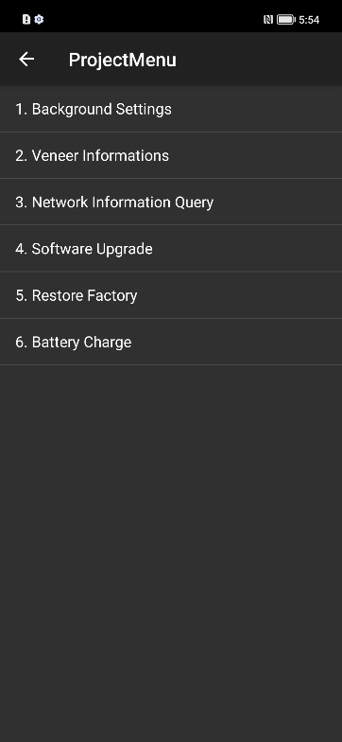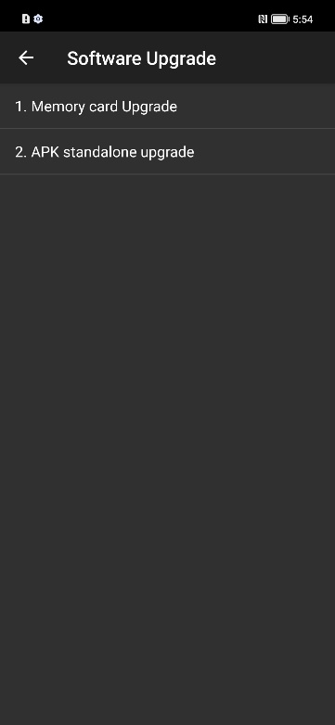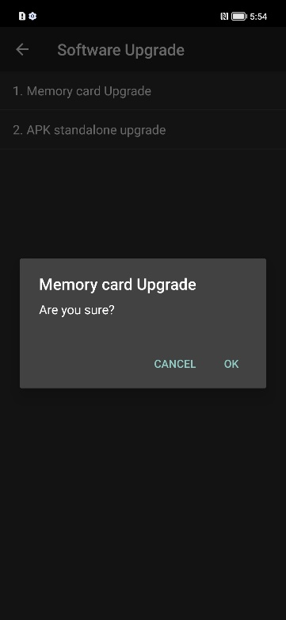

Step 6：Wait while the upgrade is being installed. The tablet will automatically reboot when the installation is complete. Note：Keep the OTG adaptor and the flash drive firmly connected until the screen shows “Update success.”

For MAGIC OS, the following screens will be shown:

手机屏幕截图

## **Forced OTG upgrade**

Step 1: Find a flash drive (preferably from well-known brands) with 8GB or more space available.

Step 2: Format this drive (optional) to exFAT, NTFS, or FAT32 file system (exFAT is recommended).



Step 3: Check if the dload folder is complete with all its contents, then copy it to the flash drive's root directory.

Step 4: Verify that all files and folders were successfully copied.

Step 5: With the tablet powered off, connect the OTG adaptor to the tablet, then the flash drive to the OTG adaptor. Press the Volume up button and the Power button simultaneously to go into the recovery menu and select “Update mode” --> Input “yes”, “Enter update mode” --> “Memory card/OTG update mode” to begin the upgrade.

Step 6：Wait while the upgrade is being installed. The tablet will automatically reboot when the installation is complete. Note：Keep the OTG adaptor and the flash drive firmly connected until the screen shows “Update success.”

For MAGIC OS, the following screens will be shown:

手机屏幕截图

## **Reset tablet**

Go to Settings > System & updates > Reset > Reset tablet, tap “Reset tablet”, then tap “Reset tablet” again to start the reset.

# Verification and troubleshooting

## **Version check**

Go into Settings ->About tablet->Build number，verify that the installed version number matches the upgrade package.

## **Basic function check**

（1）Check if the tablet can 1. power on and boot into the operating system, 2. dial and place calls, 3. be turned off by long pressing the power button.

（2）Check if all apps can run properly.

## **Troubleshooting upgrade issues**

If an issue cannot be resolved (without violating any precautions), please contact your local Honor service center.

## **Using at commends and writing customized information**

1 Make sure that USB drivers are installed on your PC.

2 Set the tablet port to Manufacture mode: in the home screen, go to the tablet’s [Calculator](https://cn.bing.com/dict/search?q=Calculator&FORM=BDVSP6&cc=cn) [interface](https://cn.bing.com/dict/search?q=interface&FORM=BDVSP6&cc=cn) -> type in ()()2846579()() -> Background settings -> USB Port Settings -> Manufacture mode.

3 Make sure debug mode is enabled on your tablet. If not, a network encryption key (can be obtained by connecting to Honor intranet) will be required to enable this mode. Vendors can contact Honor for support.

4 Use Com Wizard or network encryption key (select the PCUI port) for query and overwriting：

（1） Vendor County Info：at^vendorcountry?

（2） Write Vendor County Info：at^vendorcountry=xxx/xx, such as: at^vendorcountry=def/la.

（3） Product internal model: at^devmodel?

（4） Overwrite product internal model: at^devmodel=yyy-yy, such as: at^devmodel=KJR-L09.